Baby Names Database

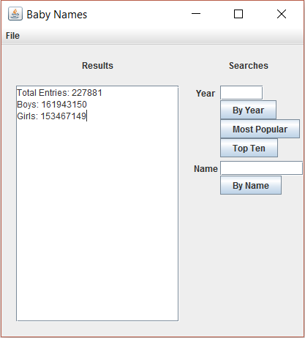

Silas Agnew

I pledge that this work is entirely mine, and mine alone (except for any code provided by my instructor).

I spent 6 hours and 5 minutes on the project from Oct. 29 to Nov. 9, See time sheet on back for more details.

Time Sheet

|  |  |  |  |  |
| --- | --- | --- | --- | --- |
| Date | Time Started | Time Stopped | Duration | Worked on… |
| 10/29/2017 | 21:00:00 | 22:20:00 | 01:20:00 | Setting up project and writing parsing methods |
| 10/30/2017 | 16:05:00 | 16:25:00 | 00:20:00 | Search methods and comments |
| 10/30/2017 | 23:15:00 | 23:45:00 | 00:30:00 | Testing DB methods and top ten method |
| 10/31/2017 | 00:00:00 | 00:20:00 | 00:20:00 | GUI work |
| 11/2/2017 | 14:00:00 | 15:20:00 | 01:20:00 | Display methods and testing |
| 11/7/2017 | 20:30:00 | 22:00:00 | 01:30:00 | Final testing, formatting, and commenting |
| 11/9/2017 | 14:45:00 | 15:30 | 00:45:00 | Formatting and Print-out |
|  |  |  |  |  |
|  |  | Total Time | 06:05:00 |  |